|  |  |  |  |  |  |  |  |  |  |  |  |  |  |  |  |  |  |  |  |  |  |  |  |
| --- | --- | --- | --- | --- | --- | --- | --- | --- | --- | --- | --- | --- | --- | --- | --- | --- | --- | --- | --- | --- | --- | --- | --- |
|  | **INTERSTATE CONTAINER CORPORATION** | | | ***Date:* 04/12/2016** | ***Spec #:*** | | | | | | | | | | ***Design #:*** | | **160389-02** | |  |  |  |  |  |
|  |  |
|  | ***Customer:* DeMet's Candy** | |  |  |  |  |  |  |  |  |  |  |  |  |  |  |  |  |  |  |  |  |  |
|  |  |  |  |  |  |  |  |  |  |  |  |  |  | ***Cut*** |  | **162 in.** | | | |  |  |
|  |  |  |  |  |  |  |  |  |  |  |  |  |  |  |  |  |
|  | ***Description:* Shipper 6.4 oz Tray Holiday 12 ct. [Left Handed 1/4"gap]** | | | |  |  |  |  |  |  |  |  |  |  |  |  |  |  |
|  |  |  |  |  |  |  |  |  |  |  |  | ***Crease*** |  | **125 in.** | | | |  |  |
|  |  |  |  |  |  |  |  |  |  |  |  |  |  |  |
| ***Style:* RSC** | | | ***Revision Info:* [0] 04/12/2016:** |  |  |  |  |  |  |  |  |  |  |  |  |  |  |  |
|  |  |  |  |  |  |  |  |  |  |  |  |  |  |  |  |  |  |  |  |
|  |  |  |  |  |  |  |  |  |  |  |  |  |  |  |  |  |  |  |  |
| ***I.D. :* 10+3/16 x 7+1/2 x 13+3/8** | | | ***Blank size:* 21+3/16 x 37+3/8** |  |  |  |  |  |  |  |  |  |  |  |  |  |  |  |  |  |  |  |  |
|  |  |  |  |  |  |  |  |  |  |  |  |  |  |  |  |  |  |  |  |
| ***Board:* 32 C K** | | | ***Combination:* 35HP - 23M - 35HP** | ***Designer:* Alan Groff** |  |  |  |  |  |  |  |  |  |  |  |  |  |  |  |  |  |  |  |
|  |  |  |  |  |  |  |  |  |  |  |  |  |  |  |  |  |  |  |
|  |  |  |  |  |  |  |  |  |  |  |  |  |  |  |  |  |  |  |  |  |  |  |  |
|  |  |  |  |  |  |  |  |  |  |  |  |  |  |  |  |  |  |  |  |  |  |  |  |

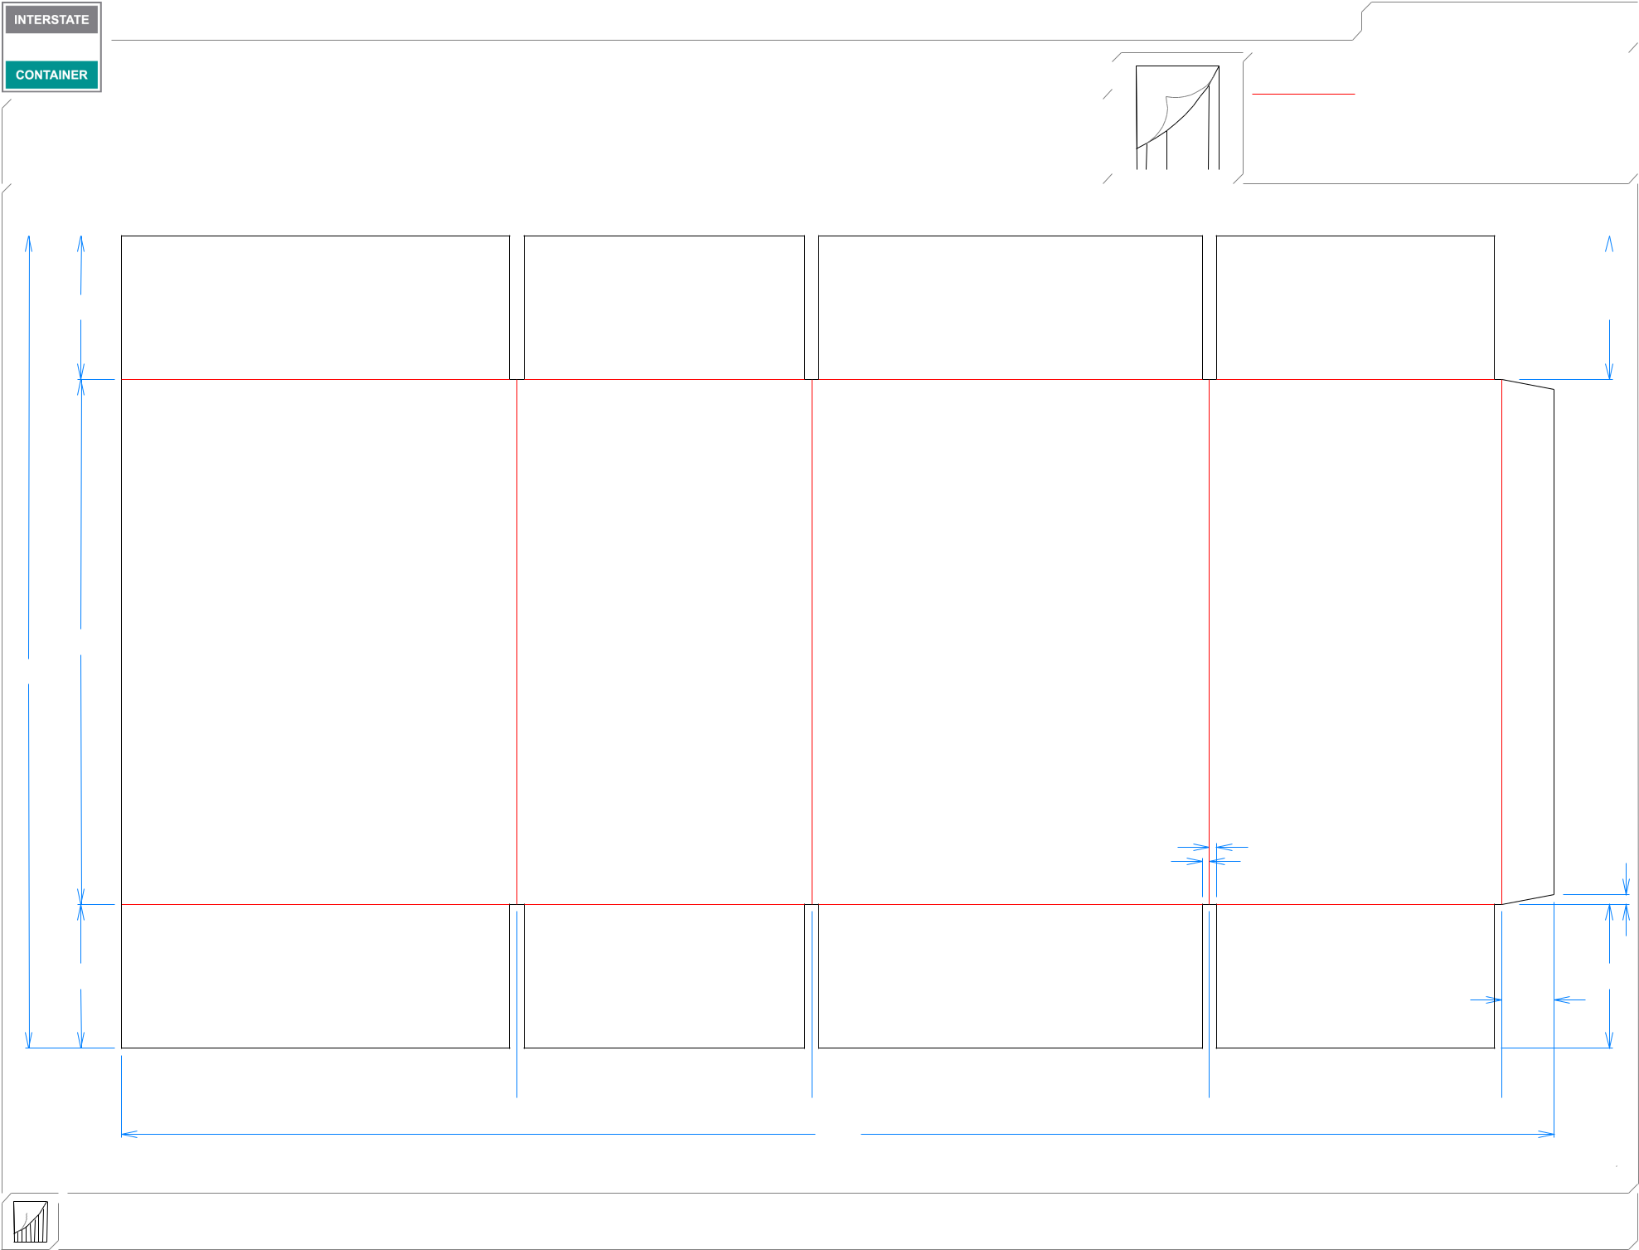

|  |  |
| --- | --- |
| 33*/*4 | 33*/*4 |

3*/*16  3*/*16

1311*/*16

213*/*16

|  |  |  |  |  |
| --- | --- | --- | --- | --- |
|  | 3*/* | 1 |  |  |
| 3 | 16 | */* | |  |
|  |  | 4 |  |
| */*16 | |  |  |  |
| 33*/*4 |  | 33*/*4 |  |  |
|  |  | 13*/*8 |  |  |

 105*/*16  711*/*16  103*/*8  75*/*8 

373*/*8

**inside view**

**Vertical Corrugation**

***notes:***

***Qty/unit:*** ***Area - waste:* 5.36 sq. ft** ***Waste on blank:* 2.6%** ***Piece weight - waste:* 0.56 lbs./254.79 g**